* VPR_setup

(Assuming the VTR tool is already been setup)

**Running VPR of presynthesized circuit: tseng circuit**

1. PartA- presynthesized circuit tseng.blif (synthesized file of tseng circuit) with Earch.xml(FPGA architecture)

commands and procedure:

Create a directory:

**mkdir -p vtr_work/quickstart/vpr_heera**

**cd ~/vtr_work/quickstart/vpr_heera**

**$VTR_ROOT/vpr/vpr $VTR_ROOT/vtr_flow/arch/timing/EArch.xml $VTR_ROOT/vtr_flow/benchmarks/blif/tseng.blif --route_chan_width 100**

Snapshot of the VPR completion for tseng circuit

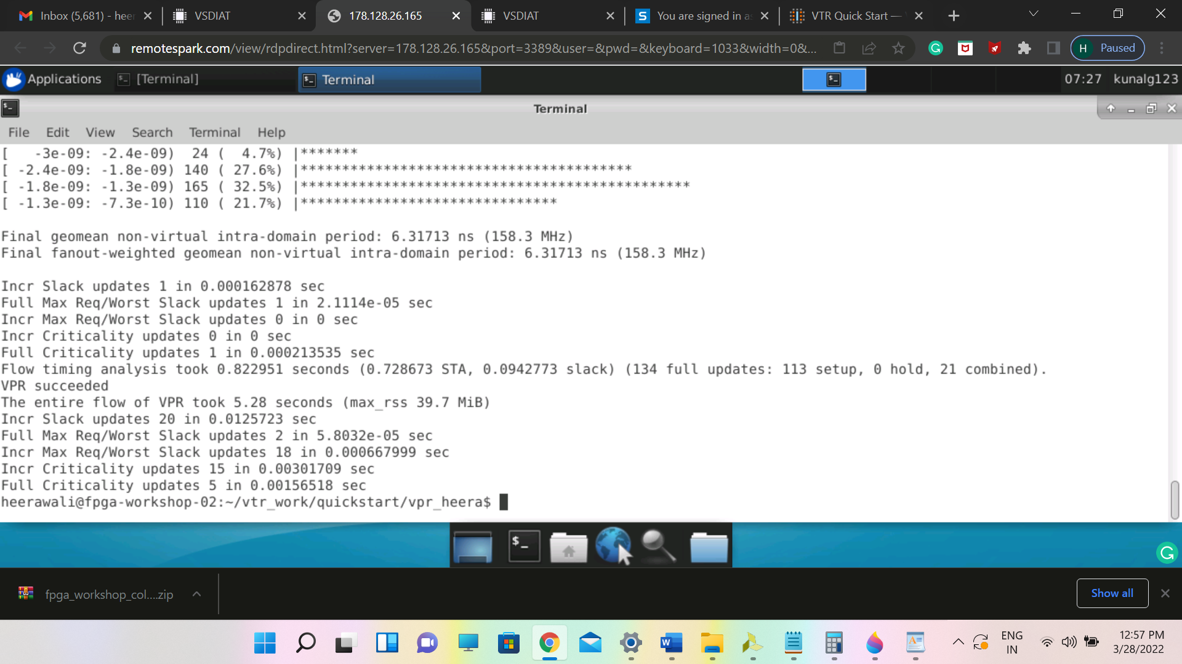

Snapshot of files listed after VPR flow of tseng circuit

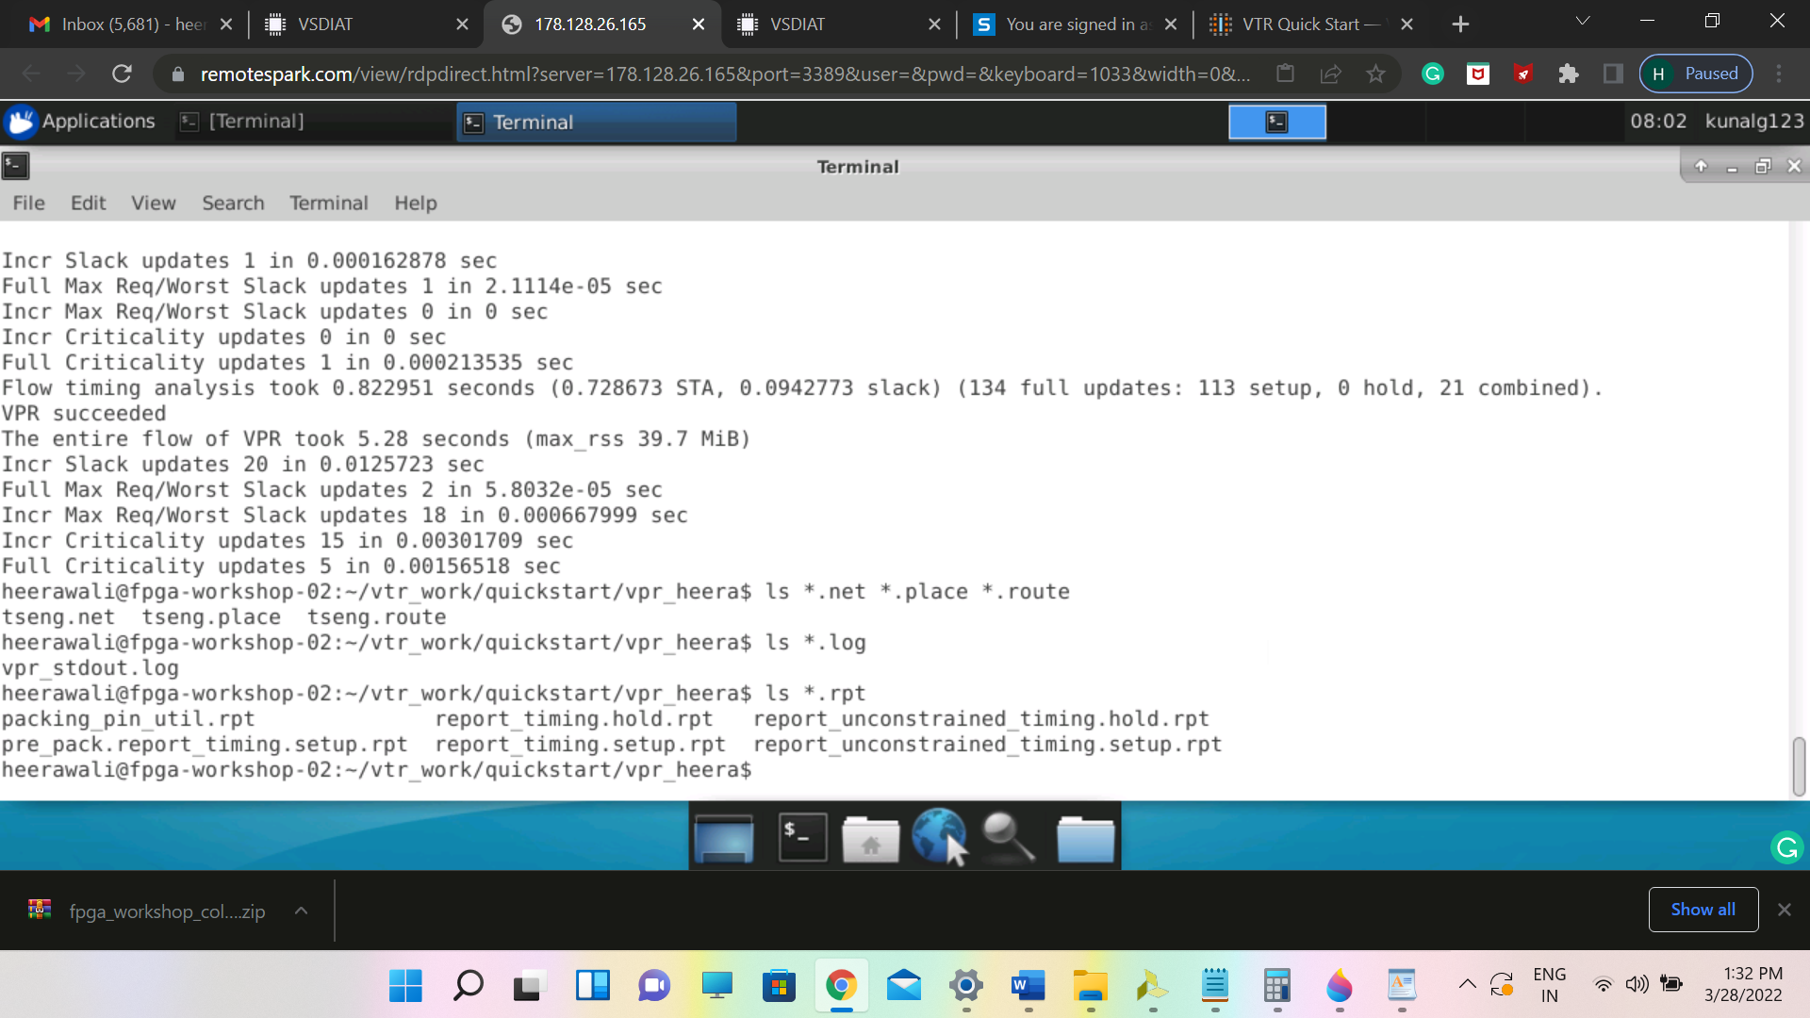

Visualizing Circuit implementation

command:

**$VTR_ROOT/vpr/vpr $VTR_ROOT/vtr_flow/arch/timing/EArch.xml $VTR_ROOT/vtr_flow/benchmarks/blif/tseng.blif --route_chan_width 100 --analysis --disp --on**

Snapshot of circuit visualization -I

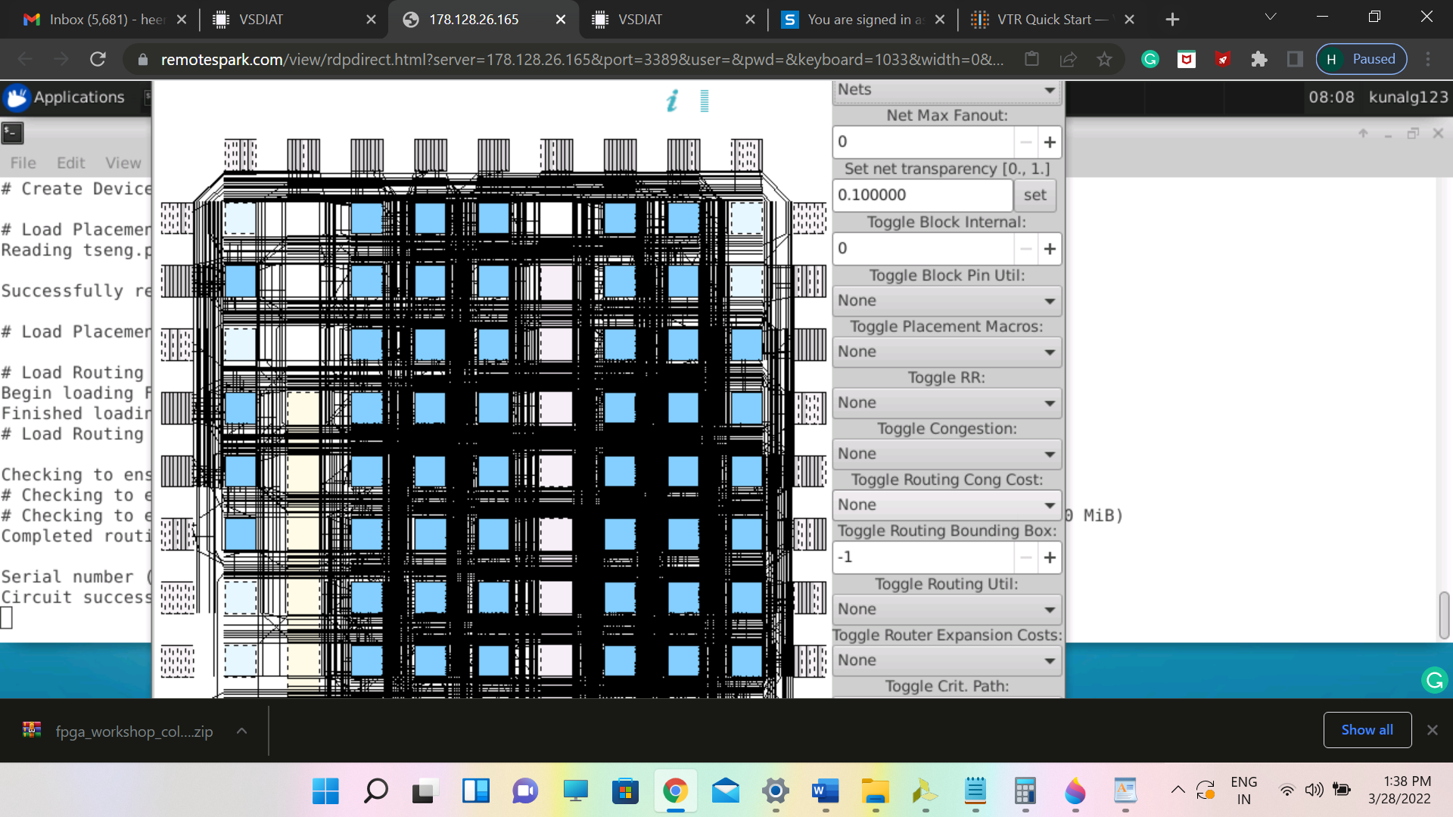

Snapshot of circuit visualization -II

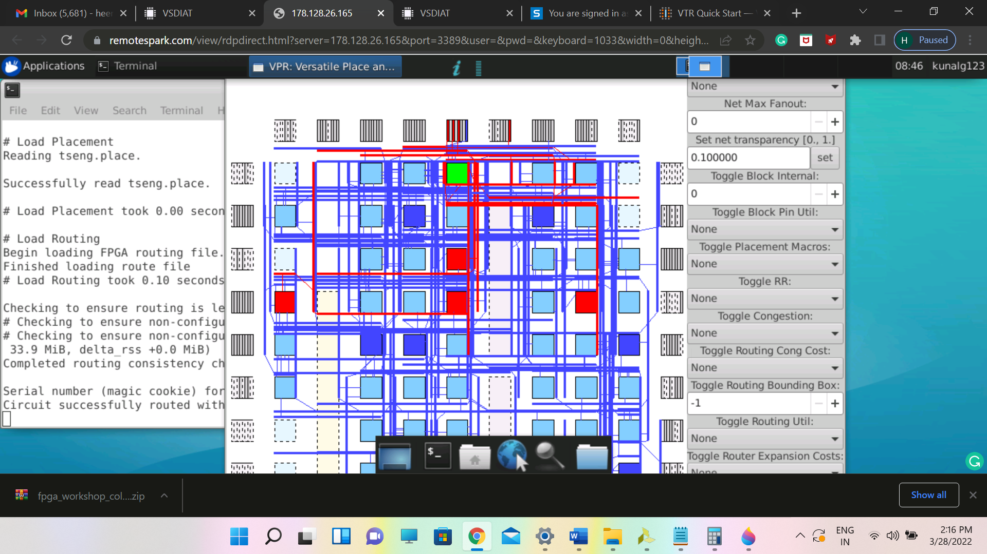

2. PART B - Running VTR (entire flow) on our own verilog file: blink.v

commands:

**cd ~/vtr_work/quickstart/blink_manual**

**$VTR_ROOT/ODIN_II/odin_II -a $VTR_ROOT/vtr_flow/arch/timing/EArch.xml -V $VTR_ROOT/doc/src/quickstart/blink.v -o blink.odin.blif**

Snapshot after running odin II

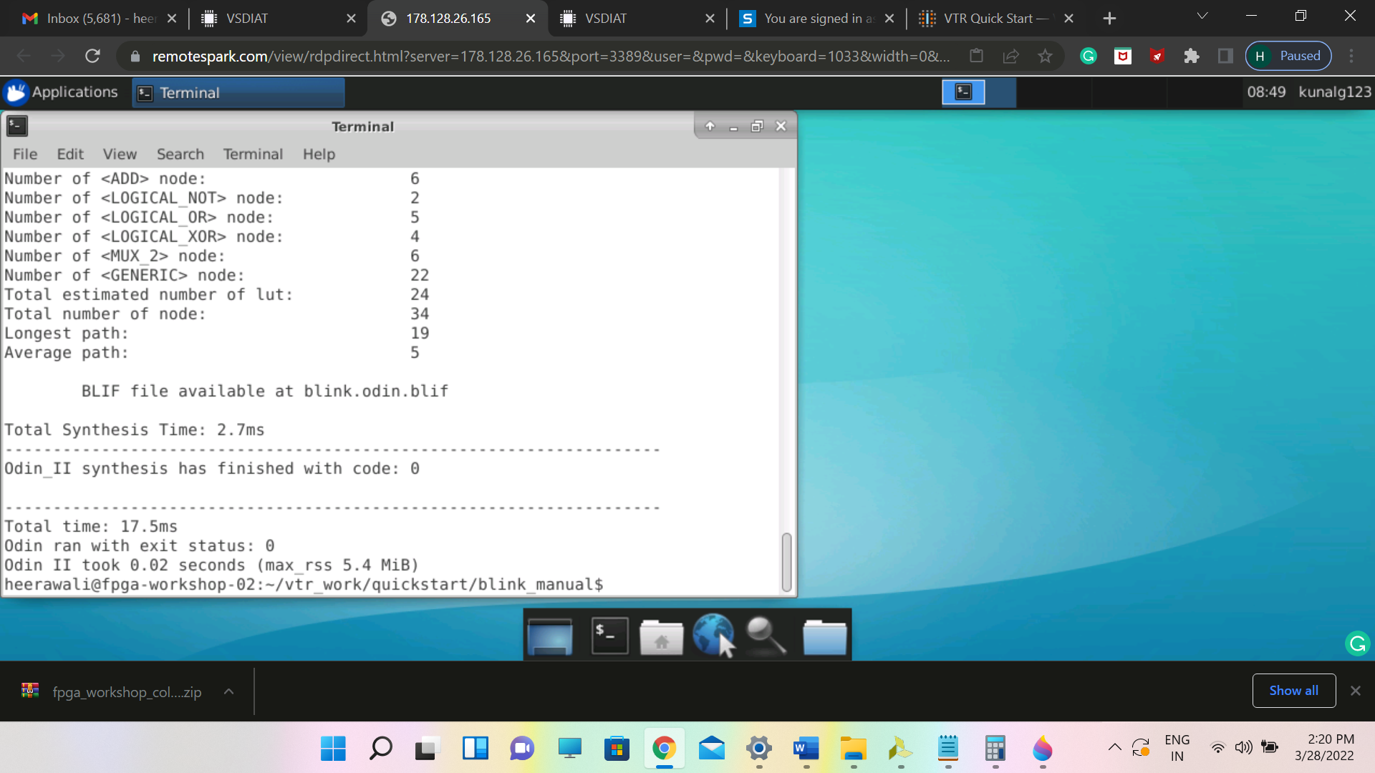

Optimizing and Technology Mapping with ABC

**Command:**

**$VTR_ROOT/abc/abc -c 'read blink.odin.blif; if -K 6; write_hie blink.odin.blif blink.abc_no_clock.blif'**

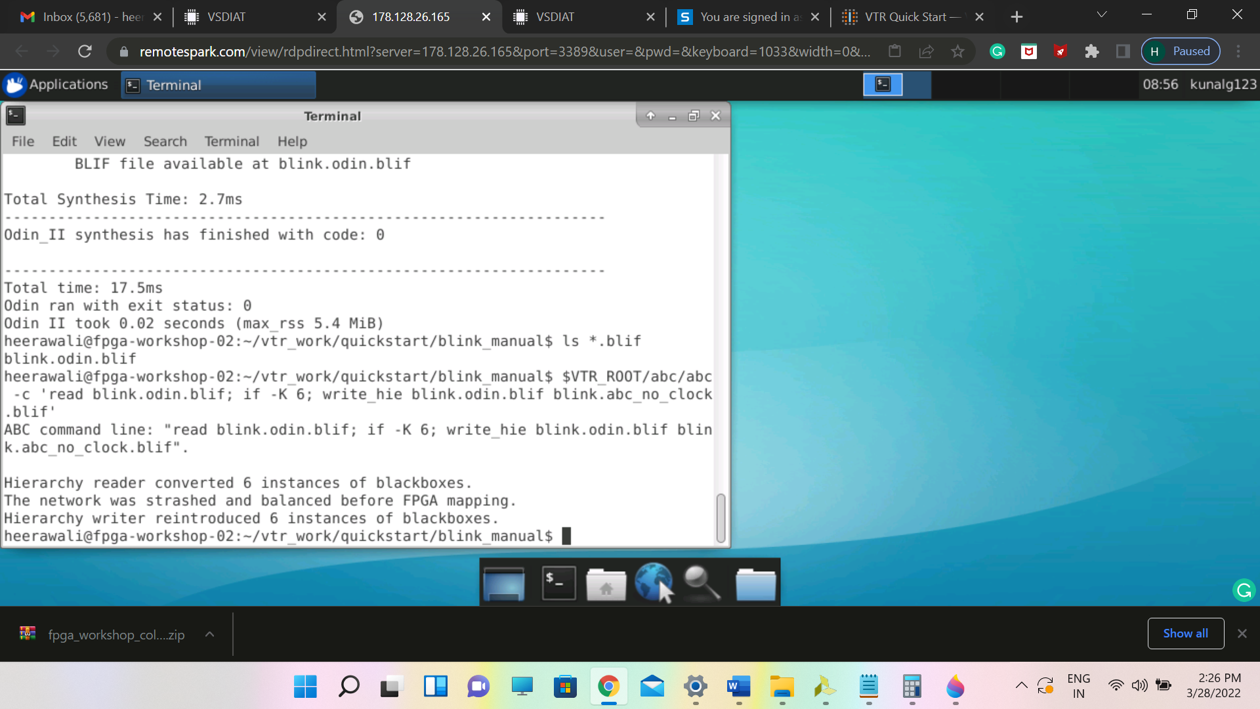

Adding the clocks in generated blif file

**Command:**

**$VTR_ROOT/vtr_flow/scripts/restore_multiclock_latch.pl blink.odin.blif blink.abc_no_clock.blif blink.pre-vpr.blif**

Affirming addition of clock in blif files

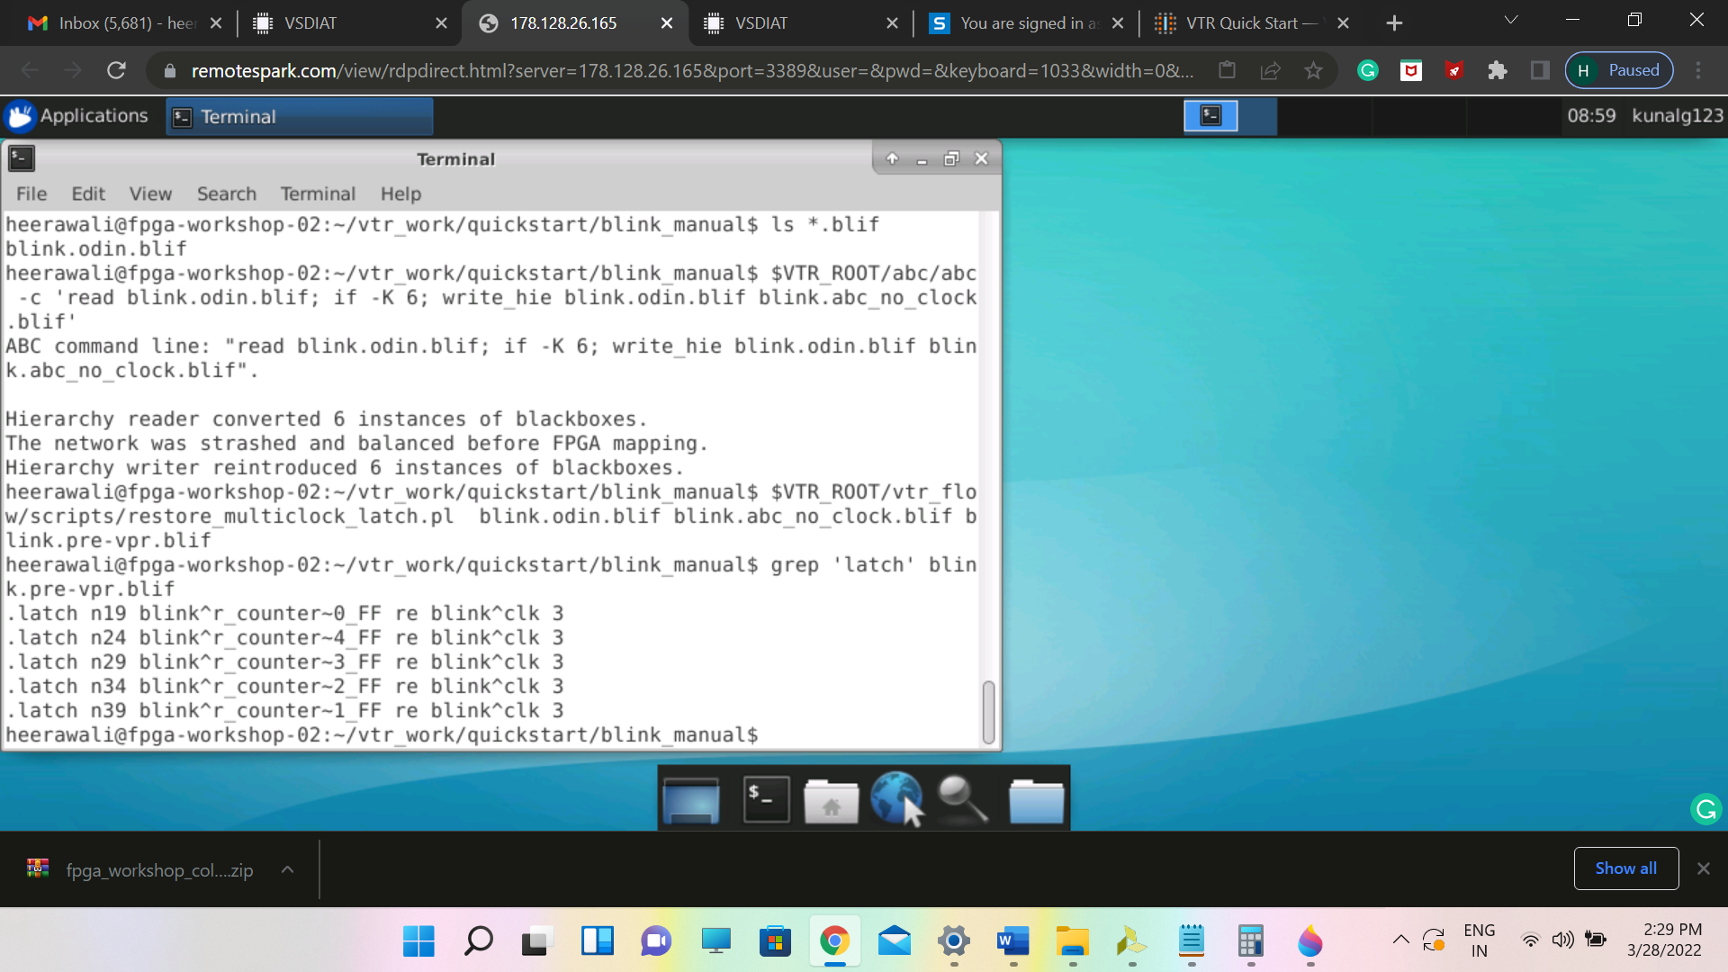

Implementing the circuit with VPR

Command:

**$VTR_ROOT/vpr/vpr $VTR_ROOT/vtr_flow/arch/timing/EArch.xml blink --circuit_file blink.pre-vpr.blif --route_chan_width 100**

Snapshot of the VPR completion for blink_led circuit

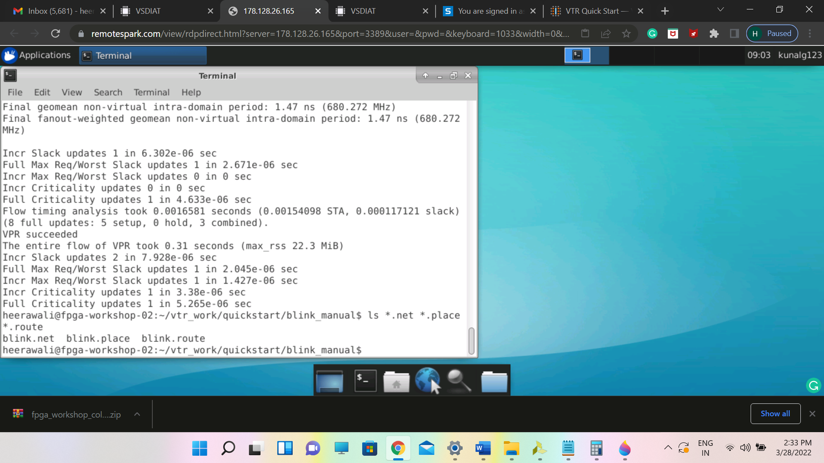

Snapshot of circuit visualization

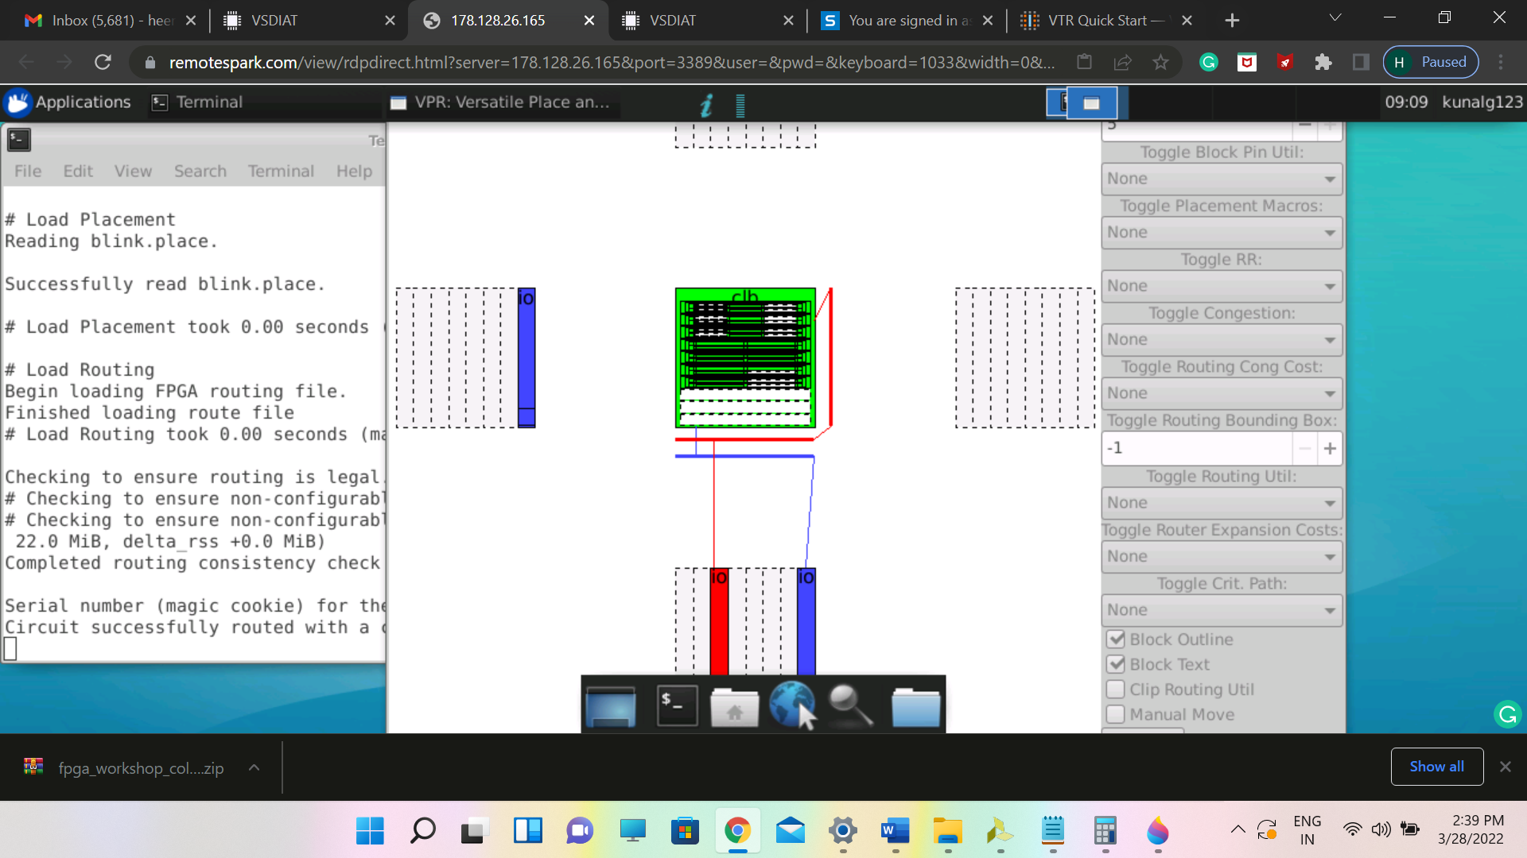

Automated flow to run the VTR

Command:

$VTR_ROOT/vtr_flow/scripts/run_vtr_flow.py $VTR_ROOT/doc/src/quickstart/counter.v $VTR_ROOT/vtr_flow/arch/timing/EArch.xml -temp_dir . --route_chan_width 100

Snapshot after running automated python script of the entire VTR flow on counter.v file

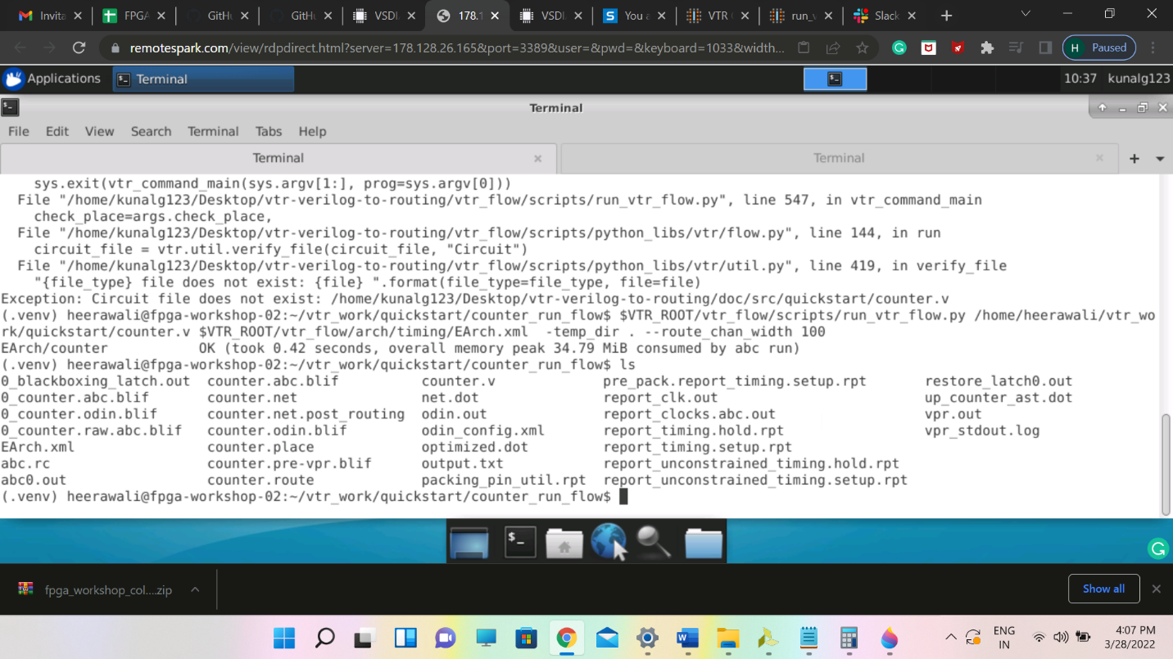  
Visualization on GUI

Command: $VTR_ROOT/vpr/vpr $VTR_ROOT/vtr_flow/arch/timing/EArch.xml counter --circuit_file counter.pre-vpr.blif --route_chan_width 100 --analysis --disp on

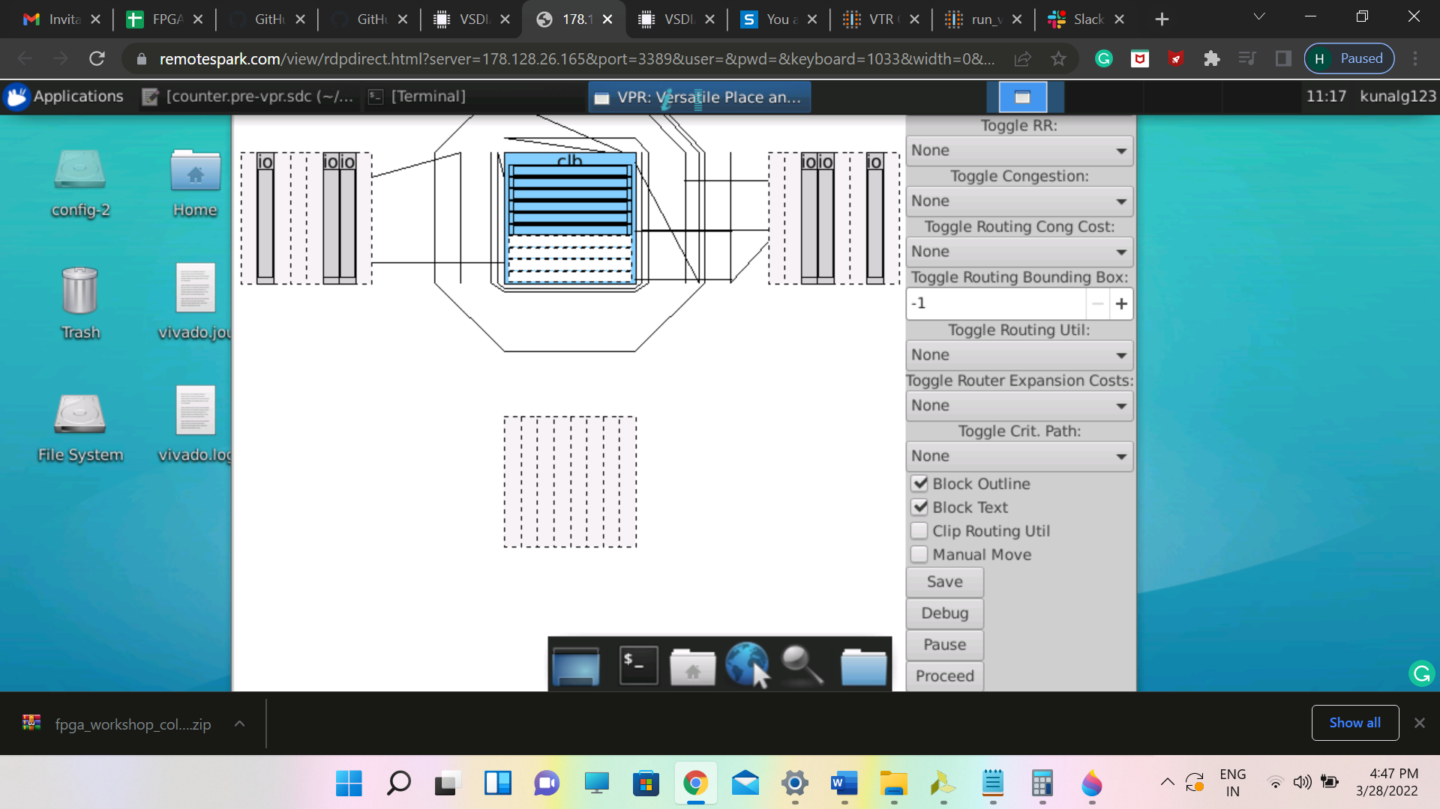

Command: $VTR_ROOT/vpr/vpr $VTR_ROOT/vtr_flow/arch/timing/EArch.xml counter --circuit_file counter.pre-vpr.blif --route_chan_width 100 --disp on (with analysis off)

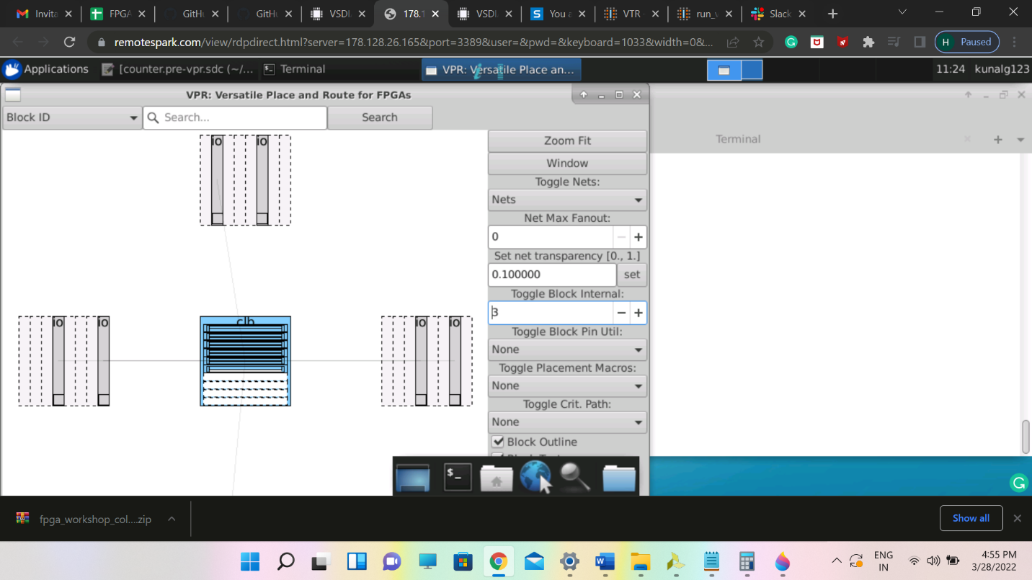

Generating post Implementation netlist

Command: $VTR_ROOT/vpr/vpr $VTR_ROOT/vtr_flow/arch/timing/EArch.xml counter --circuit_file counter.pre-vpr.blif --gen_post_synthesis_netlist on

